Raymond Delgado

CIS 5430

Homework 05

* 1. Simplified Automobile Insurance Company

1. Star schema:

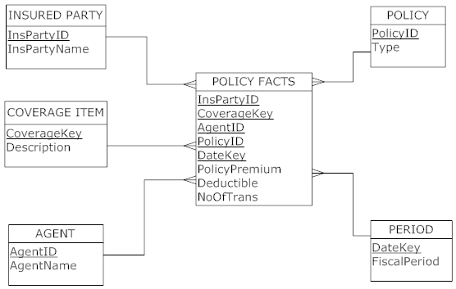

The total numbers of rows:

* Insured Party: 2
* Coverage Item: 10
* Agent: 1
* Policy: 1,000,000
* Period: 1 year (12 months)

Total numbers of rows = 2 \* 10 \* 1 \* 1,000,000 \* 12 = 240,000,000

The total number of bytes for a fact table:

* Number of fields: 8
* Number of bytes per fields: 10
* Number of rows

Data Size of the fact table: 8 \* 10 \* 240,000,000 = 19,200,000,000 bytes or 19.2 GB

The total number of rows:

* Insured Party: 2
* Coverage Item: 10
* Policy: 1,000,000
* Number of claims: 2,000

Total rows: 2 \* 10 \* 1,000,000 \* 2,000 = 40,000,000,00 rows

